


Sanlam All in One
Learner Guide

Contents


Welcome 43
Introduction 65
Section 1: Product Overview...... Error! Bookmark not defined.Error! Bookmark not defined.9
  - Benefits offered 879
  - Disability Payout 8711
  - Existing cover 9812
  - Role-players on the policy . Error! Bookmark not defined.Error! Bookmark not defined.12
  - Age limits........................... Error! Bookmark not defined.Error! Bookmark not defined.14 Section 2: Exclusions 111016
  - Non-disclosure 111016
  - Risky activities 131217
  - Disability additional exclusions 151417
  - Industry standards 161518
Section 3: Product Underwriting 212019
  - The underwriting process 282719
  - Application process 282719
  - Underwriting questions ...... Error! Bookmark not defined.Error! Bookmark not defined.20 Section 4: Claims 343322
  - Conditions for Claim Payments 343322
    - Claim Notification Period 343322
    - Currency ..................... Error! Bookmark not defined.Error! Bookmark not defined.22
  - Unclaimed Benefit ............. Error! Bookmark not defined.Error! Bookmark not defined.22
  - Claims payment documentation Error! Bookmark not defined.Error! Bookmark not
defined.23
Section 5: Alterations ............... Error! Bookmark not defined.Error! Bookmark not defined.25
  - Amendments to the role-players Error! Bookmark not defined.Error! Bookmark not
defined.25
  - Amendments to the policy terms, premiums and cover levels Error! Bookmark not
defined.Error! Bookmark not defined.25
    - Change in term ........... Error! Bookmark not defined.Error! Bookmark not defined.25
    - Change in premium and cover growth.. Error! Bookmark not defined.Error! Bookmark not defined.25
    - Increasing the cover level Error! Bookmark not defined.Error! Bookmark not
defined.26
    - Decreasing the cover level Error! Bookmark not defined.Error! Bookmark not
defined.26
Section 6: General .................... Error! Bookmark not defined.Error! Bookmark not defined.28
  - Date and terms.................. Error! Bookmark not defined.Error! Bookmark not defined.28
    - Issue date ................... Error! Bookmark not defined.Error! Bookmark not defined.28
    - Collection Date............ Error! Bookmark not defined.Error! Bookmark not defined.28
    - Policy Anniversary....... Error! Bookmark not defined.Error! Bookmark not defined.29
    - Signature Date ............ Error! Bookmark not defined.Error! Bookmark not defined.29
    - Cover Start Date ......... Error! Bookmark not defined.Error! Bookmark not defined.29
    - Acceptance Date......... Error! Bookmark not defined.Error! Bookmark not defined.29
    - Reinstatement Date .... Error! Bookmark not defined.Error! Bookmark not defined.29
    - Policy End Date .......... Error! Bookmark not defined.Error! Bookmark not defined.29
  - Premiums .......................... Error! Bookmark not defined.Error! Bookmark not defined.30
    - Premium rates............. Error! Bookmark not defined.Error! Bookmark not defined.30
    - Premium escalations... Error! Bookmark not defined.Error! Bookmark not defined.30
    - Policy fee .................... Error! Bookmark not defined.Error! Bookmark not defined.30
    - Premium collection...... Error! Bookmark not defined.Error! Bookmark not defined.30
    - Premium payment term Error! Bookmark not defined.Error! Bookmark not
defined.31
    - Guarantee and the Right to Review Error! Bookmark not defined.Error! Bookmark
not defined.31
  - Waiting periods.................. Error! Bookmark not defined.Error! Bookmark not defined.31
  - Cooling off period .............. Error! Bookmark not defined.Error! Bookmark not defined.31
  - Lapse ................................ Error! Bookmark not defined.Error! Bookmark not defined.31
  - Reinstatement ................... Error! Bookmark not defined.Error! Bookmark not defined.32
  - Cessions ........................... Error! Bookmark not defined.Error! Bookmark not defined.32
  - Loans ................................ Error! Bookmark not defined.Error! Bookmark not defined.32
  - Who receives the benefit ... Error! Bookmark not defined.Error! Bookmark not defined.32

Welcome
Purpose

This guide will help you to:

Demonstrate understanding of the Sanlam All in One plan

Target Audience
The target audience for this learning intervention includes: Financial Advisers
Call Centre Staff Policy Servicing Staff
Claims Staff (those who sell the product)

What is the objective?

By the end of this course you should be able to:
Identify the target market for this product Explain the structure of the product Explain the features of the product
Understand the benefits of having the product Describe other terms and conditions of the product
Activity icons

 | Classroom activity  When you need to participate in a classroom activity.
 | Examples  This icon indicates examples relevant to the section.
 | Important notes  Indicates hints, things to remember and important information

Introduction
What is the Sanlam All in One Plan?
The All in One Plan is designed to offer better value for clients
- That have complex risk needs (like large families, high cover amounts, and flexible benefits) for whom traditional policies aren't adequate.
- With large and/or confusing portfolio's that are potentially overpaying and/or struggling to manage all their policies/deductions.

The All in One Plan is a single product that is made up of:
- Funeral Cover,
- Life Cover.
- Monthly Expense and
- Various other special features

The All in One plan can be sold in 2 ways namely: As a standalone (one product) Or
As a consolidation plan (various policies consolidate into one)

Automatic and optional features & benefits on the plan, will be covered in detail later in the course.

Why Choose All in One Plan

This product eliminates the hassle of having multiple risk policies by simply providing one plan
on which you can cover all your needs, with one affordable premium. The name says it all.

One Plan, multiple benefits, one premium, which is more affordable and easier to manage.
The plan eliminates unnecessary admin costs and duplications that are often incurred by having multiple funeral polices. The product is sold on a easy to use, guided Needs Analysis and advice tool that eliminates common errors.

The is no underwriting required.

How will I, as an advisor, know that the client needs All in One Plan?
Sales Cycle
- As an advisor, it is your responsibility to ensure that you thoroughly cover the 6 steps of the Sales Cycle with your client. If you neglect doing any of these steps, it may result in you making
an incorrect recommendation.

Point of sale
- You need to make sure the client is given clear and correct information about Sanlam, the product, etc. at point of sale. You need to ensure that you keep the client informed of all matters that impact them in any way while you are conducting the sale.
Financial Needs Analysis
- you must thoroughly complete FNA and it indicates that the client requires one plan , then All in One will provide for the client’s needs.
FAIS Act
- Under the FAIS Act it is required by law that a financial advisor conduct a thorough financial needs analysis for a client before giving them advice.
Treating Client Fairly (TCF)
- Treating Client Fairly (TCF) also says that clients must be provided with clear information and that they are kept appropriately informed before, during and after point of sale and that where advice is given, it is suitable and takes account the clients situation. Cover is provided for

What the All in One plan offers:

The Sanlam All in One plan looks at simplifying the needs of the client and offers a single plan to accommodate everything, now that you have a better understanding of the All in One Plan.


Let's take a look at the benefits of having such a product. We will discuss what the benefits are, for you the adviser, the client and also for Sanlam.
Section 1: Benefits
Learning objectives By the end of this section, you will be able to:
Explain what the Sanlam All in One Plan
Explain the selling point for the All in One Plan
Why you should consider selling the All in One

As mentioned before the All in One Plan was designed to offer better value for the client and complex risk analysis, which will help with clients that have large portfolios and can be Consolidated or sell the product as a Stand Alone product. By looking at the Benefits are structured we can determine how we can sell the product better.

As an advisor it important to try and sell the All in One plan because it helps cover all the policies the client can require and eliminates any duplication one may have in regards to traditional polices, which will offer affordable premiums.

Now let’s look at the Benefits to the Client, Sanlam and the Financial Advisor?

  - Benefits for the client
The All in One offers the following benefits to the client:
    - Ease of claiming through one insurer
    - More affordable & lower premium with one admin fee instead of multiple fees
    - Smaller portfolio to manage
    - One premium deduction depending on the solution chosen (stand-alone or consolidation.
    - Can replace existing funeral cover (where appropriate) without taking risks or incurring new
waiting periods.
    - Eliminates unnecessary cost of duplications (principal life assured is not forced to be covered on all funeral policies he/she owns).

  - Benefits to Sanlam
    - Acting in the best interest of our clients
    - Improving cost-spread
    - Higher retention
    - Greater share-of-wallet
  - Benefits to Financial Adviser
    - An appealing value proposition.
    - Convenient, fast and easy to sell.
    - Competitive pricing – save your client money without sacrificing reduced cover.
    - Improved client loyalty.
    - Protection against senseless churning.
    - Growing with your clients - ability to up-sell.
    - Cover up to 30 people on one plan.
    - Higher premiums and less lapses.
    - Very high-value unconventional benefits that are rarely found on traditional products.
    - Option to have life cover pay monthly instead of a lump sum - Protecting the interests of the client’s beneficiaries
    - Cover for very large families on one plan.

Important Note:
Remember that the product is sold on an easy to use, guided Needs Analysis and advice tool that eliminates common errors.

Classroom activity
Let us take a small quiz to test our knowledge

 | True | False
The All in One plan offers the following benefits. Select the correct option from the | below.
Efficiency and cost effectiveness
One plan with funeral cover and optional life cover
Dread Disease and multiple fees
 | True | False
As an advisor the All in One plan will help you establish growth with your clients and have fewer cancellations on your policies
 | True | False

As Sanlam we always act in the best interest of Sanlam and of our Advisors, higher retentions come second to none when it comes to selling products

Section 2: Product Structure
Learning objectives
By the end of this section, you will be able to:
Explain how the All in One Plan works
Explain who may sell the All in One Plan
Explain the cover types of the All in One Plan
Identify who is eligible to have the All in One Plan
Explain how cover works
Explain how premiums work

  - How the Sanlam All in One plan works
The All in One product can be sold in one of two ways. It can be sold as a stand-alone product or by consolidating various policies that a client might have with us and/or with other insurers.

In this section we will only look at how to sell it as a standalone.

The Product
- The plan comprises of both compulsory and optional cover.

Conditions for taking the plan
- The policyholder, premium payer and principal life assured must be the same person.
- Funeral and non-underwritten life cover is provided for the whole of life.
- A minimum of R10 000 funeral cover is compulsory for the principal life assured.
- The premium of the plan will be determined by the type of cover, lives covered, entry ages, cover amounts and benefit options that are chosen.
- The product is aimed at the Mass & Middle market segment – PERSAL (Government Employees) and later to clients that have access to salary-deduction facilities.
- The minimum premium is R250 per month.

Who can sell the Product?
- Only financial advisers that have completed the All in One Plan accreditation will sell the product.
- A financial adviser must be registered as Category B1A adviser in order to sell the All in One Plan Standalone option.

∗ It is important to note that a complete comprehensive financial risk needs analysis must be done with the client to establish which product will best suit the client’s needs.

How will the product be sold?

The All in One Plan will be hosted on a system called


I-Manage Pro for ease of doing business and reducing errors. The All in One Plan is built on an electronic platform which guides and makes recommendations in order to assist the financial advisor and client.

I-Manage Pro is accessed using a web link. The system is access dependent, in other words, Sanlam needs to grant you access.

    - The product will be sold as stop order or debit order through DebiCheck.
    - DebiCheck is a secure debit order payment system that allows the client to electronically approve their Debit Orders.

  - Benefits and features offered on the product
Let us understand all the Benefits offered by the All in One plan, we will now look at each of the benefits offered by the AiO in a more detailed explanation (picture summary below):
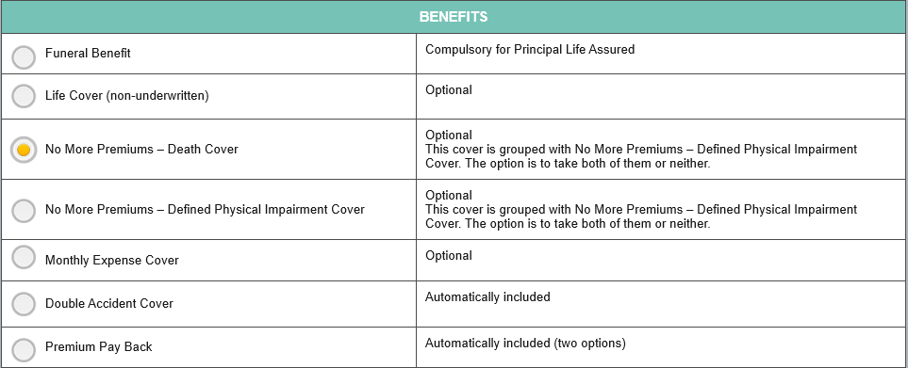

  - Funeral Cover description:
- Funeral cover, covers the client and their loved ones in the event of death.
- The sum assured will be paid out on the event of death of the life assured.
- It is compulsory on each policy for the principal life assured (PLA) to have a minimum funeral cover of R10 000.
- Total cover for Funeral including Life and Monthly Expense is subject to a limit of R500 000 per plan.

Lives Assured:

The following life types can be covered (total 30 lives).

- Principal life assured (x 1)
- Spouse (x 1)
- Child (x 8)
- Parent (x 4)
- Wider family (x 16)

Stillbirth cover Pays R1000 on the birth of a stillborn child if:

- The policyholder or the spouse of the policyholder gave birth to the stillborn child, and
- The person who gave birth is either covered as the principal life assured or a spouse under the
spouse category.
  - A “birth” before 28 weeks gestation is regarded as a miscarriage and is not covered by the stillbirth benefit.
- Upon the birth or adoption of a child, the policyholder must add the child to the policy as soon as possible.

Let us now look at what is the qualifying period on a Funeral cover: What is the qualifying period?
There is a 6 month qualifying period for death due to natural or non-accidental causes. However, this qualifying period can be waived (set aside) if:

- The policyholder, within 31 days preceding the date of entering into a new funeral policy with that insurer, had a previous policy with another insurer;
- The policy benefits under that previous policy provided cover in respect of similar risks relating to the same lives insured as those covered under the funeral policy, and
- The policyholder had completed the waiting period in respect of that previous policy.

During the qualifying period funeral cover will pay out if the death occurred by accident. Suicide, which is treated as non-accidental causes, has a 6 month qualifying period which starts when cover starts

- A qualifying period of 6 months for death due to natural causes will apply to a new child
added.
- Should the child be younger than 6 months old and dies due to natural causes within the 6-month qualifying period, the full benefit will not be payable however an amount of R1,000.00 will be paid.
- Should the child be older than 6 months old and passes away due to natural causes within the 6-month qualifying period, no benefit will be payable
- If a child has been added to the policy and the child dies due to an accident, the full benefit
amount will be payable as there is no qualifying period for accidental death.

Children legislative cover limits

The maximum policy benefits payable in terms of the Long-term Insurance Act for minor children below 14 years are as follows:
- Maximum R20 000 - Children between 0 - and before a child’s 6th birthday
- Maximum R50 000 - When a child is between their 6th and 14th birthday
- There are no legislative limits for children aged 15 and older, which means that we will payout whatever cover was selected for them. in addition, escalations, double and triple accidental cover applies to these children.
When does this cover end?

The cover for this will end on the first of:
- When the policy ends,
- When the life assured is removed from the policy; or
- When the life assured dies

  - Life Cover description:
- Life cover provides cover to the Principal Life Assured and Spouse under the policy.
- The sum assured will be paid out on the event of death of the life assured.
- The policyholder can choose, at point of sale (policy inception or when desired thereafter), if they want to be paid as a lump sum or in equal payments of 12, 24, 36, 48 or 60 months.
- There is no underwriting on this cover.
- Total cover for Funeral including Life and Monthly Expense is subject to a limit of R500 000 per plan.

Lives Assured

The following life types can be covered.
- Principal life assured
- Spouse

Qualifying Period

- There is a 6-month qualifying period for this cover which begins when cover starts.
- During the qualifying period the benefit will pay out if the death occurred by accident.
- Suicide, which is treated as non-accidental causes, has a 12 month qualifying period which starts when cover starts
When does this cover end?


The cover for this benefit will end on the first of:

  - When the policy ends,
  - When the life assured is removed from the policy; or
  - When the life assured dies.

Conditions

- The beneficiary (other than the policyholder) cannot change the number of installments.
- The benefit value will be held in a zero interest bearing account until each installment is paid.
- Different lives assured are entitled to different cover levels up to the maximum allowed by Sanlam.

  - Burial Repatriation description
- Burial Repatriation may be changed or stopped at any time without notice from Sanlam.
- This service will not be exchanged for cash.
- It is arranged for the client by Sanlam and is not provided by Sanlam but by a third party.
- Sanlam will notify the client as soon as possible when this has changed or has been canceled.
- This service is provided by another company, Sanlam will not be liable for losses, damages or expenses arising from the use of the service even if such losses, damages or expenses are caused by the negligence of Sanlam.

The following funeral support services are available in respect of a life assured:

- Repatriation closest to the place of burial. The place of death must fall within the Republic of South Africa, Namibia, Zimbabwe, Botswana, Swaziland, Lesotho and Mozambique (south of the 22° parallel). The place of burial must fall within the Republic of South Africa.
- Transportation arrangements for a single relative to accompany the mortal remains to the nearest funeral home of choice closest to the place of burial.
- Accommodation for a maximum of one night, if required, for a single relative accompanying the mortal remains to place of burial.
- Legal assistance regarding the funeral procedures e.g. death certificate, removal of body, etc.
- Assistance in the arrangement of a funeral or cremation, all funeral costs are for the account of the policyholder and not Sanlam.
- Assistance in obtaining a death certificate.
- If required, referrals to a pathologist, psychologist, psychiatrist, or special counselling (particularly relating to the loss of a child).

Lives Assured
All lives covered on the policy.

Premium
The premium is included in the Funeral Cover premium.

Qualifying Period
There is no qualifying period for this benefit.
When does this benefit end?

The cover for this benefit will end on the first of:


- When the policy ends;
- When the life assured is removed from the policy;
- When the life assured dies.

  - Double Accident Cover description
- The double accidental cover is an amount equal to the Funeral Cover amount that will be paid if the life assured dies in an accident.
- This is only applicable to the Funeral Cover.

Lives Assured
The following life types can be covered.

- Principal life assured
- Spouse
- Child
- Parent
- Wider Family

Qualifying Period
There is no qualifying period. When does this benefit end?
The cover for this benefit will end on the first of:


  - When the policy ends,
  - When the life assured is removed from the policy; or
  - When the life assured dies

Terms and Conditions
  - Double accident will be paid but is limited to a maximum legal limit for children.
  - Any excess over the maximum cover allowed for a child will not be paid out.
  - Premium Pay Back
- Premium Pay Back, is cash back and will be paid out to the Policyholder on the 15th policy anniversary
- The policy must be active
- The Policyholder must be paying premiums on the date that it is due.
- The policyholder will have the choice when buying the policy of either a 50% or 100% premium pay back payment of all the premiums paid as a premium pay back or activate a paid-up status.
- The life assured for which the premium pay back is being paid on must be alive at the time of this claim in order for the premium pay back to be paid on it.

Option
The policyholder at claim stage will be given 2 options.

Option A:
- Receive an amount of money equal to the percentage selected at the start of the policy.
- These are the net premiums that were received and allocated to the policy over the last 15 years.
- The amount excludes premiums that were allocated in respect to cover increases, and/or lives that started less than 10 years ago and, premiums that were paid on lives were claims were paid.

Option B:
- Provided that the policyholder has reached the age of 65 (on the first policy anniversary after their 65th birthday);
- have all future premiums waived, on all the risk benefits (funeral, life cover, grocery/assistance benefits) that are active at that point.
- Excluding any benefits and/or cover-increases and/or lives that started fewer than 10 years ago.
- Upon exercising this option, the Funeral Cover and Life Cover remains intact, premium escalations (and cover increases) end.

For example:
William is a 40 year old male. He decided to take up insurance with Sanlam. The adviser explained the options under the Premium Payback cover to him.

Option A: He has a choice to receive premiums paid back when the policy reaches 15 years. If he chooses to take his premiums back. The paid up status will not be activated when he reaches the age of 65. This means he will keep paying premiums for 10 more years and only after the 10 years will the paid up status be activated on the policy.

Option B: If he however chooses the option not to take his premiums back when the policy reaches 15 years. The paid up status will be activated when he reaches the age of 65. This means he will not pay anymore premiums for the rest of the life of the policy. The Funeral Cover and Life Cover remains intact, premium escalations end and cover increases.

Option A is a once off event and does not repeat after every 15 years. After the premium pay back has been paid, William must pay premiums again for a maximum of:

- 10 years, or
- Until age 65

  - No More Premiums – Death Cover description
If the policyholder dies before their 65th birthday, all lives assured will be covered on the policy until the policy anniversary after the Policyholder would have turned 65 without further payment of any premium.

Lives Assured
- Policyholder

Premium
- There is an additional premium for this and the No More Premiums - Defined Physical Impairment Cover.
- The premium will be set as a percentage of the Funeral, Life and Monthly Expense Cover premium.
- The percentage differs by the plan chosen.

What is the qualifying Period?
- The qualifying period is 6 months.
- During the qualifying period, cover will apply if the death is due to an accident.
- If a life is added to the contract within the 6 months before the death of the policyholder, the premium for that life will not be covered by the No More Premiums cover, unless the death of the policyholder is due to an accident.
When does this benefit end?

The cover will end on the first of:
- The policy anniversary, after the policyholder turns 65 or
- The death of the life assured
- When the policy ends
- If this cover is removed from the policy

Terms and Conditions
- No new lives can be added when this is in operation.
- No alterations in cover amounts will be allowed once it is in operation.

When this cover is in operation the following will stop:


  - Premium Payback
  - Policy Break
  - Escalations and
  - Any other No More Premium cover

  - No More Premiums – Defined Physical Impairment Cover description
- If before the policy anniversary, after the policyholder’s 65th birthday and the policyholder becomes permanently and totally physically impaired according to policy definition. Sanlam will waive all premiums on the policy.
- If the policyholder dies, while this benefit is in operation, the No More Premiums - Defined Physical Impairment cover will end and the No More Premiums - Death cover will start.

Life Assured
- Policyholder

Premium
- There is an additional premium for this and the No More Premiums – Death Cover
- The premium will be set at a certain percentage of the Funeral, Life and Monthly Expense Cover premium.

What is the qualifying Period
- The qualifying period is 6 months.
- During the qualifying period, the benefit will apply if the physical impairment is due to accidental causes.
- If a life is added to the contract within the 6 months before the physical impairment of the policyholder, the premium for that life will not be covered by the No More Premiums cover, unless the physical impairment is due to accidental causes.

When does this benefit end?
The cover will end on the first of:

- When the policy ends
- The policy anniversary, after the policyholder turns 65 or
- The death of the life assured
- If this cover is removed from the policy

Terms and Conditions
- No new lives can be added when this is in operation.
- No alterations in cover amounts will be allowed once this is in operation

When this cover is in operation the following will continue:
- Funeral Cover
- No More Premiums – Death Cover


- Double Accident
- Grocery Cover

When this is in operation the following will stop:
- Policy Break
- Escalations
- Premiums Payback
- Premiums Paid-up

Exclusions: No exclusions will be made for pre-existing conditions.

  - Monthly Expenses Cover description

- This cover provides monthly payments for a specified time on the event of death of the life assured.
- This cover is optional.
- Total cover for Funeral including Life and Monthly Expense is subject to a limit of R500 000 member per plan.

Lives Assured
The following life types can be covered.

- Principal life assured
- Spouse
- Parents
- Wider family members over the age of 26 when cover started
Cover and Premium
- The initial cover amount is R1 000 per month per life assured at the start.
- It will be paid monthly for 12, 24 or 36 months.
- The number of installments are chosen at point of sale

What is the qualifying Period?
- There is a 6 month qualifying period for this cover which begins when cover starts.
- During the qualifying period this will pay out if the death occurred by accident.

Payment of the Claim

- The first payment will be on the first working day of the month after the death of the life assured if Sanlam was notified on time, subsequent payments will happen monthly thereafter.
- If a claim is submitted where the date of death is backdated, a single payment for the months prior to the current date of the cover will be paid and the remaining months will be paid on the first working day of each subsequent month.
- The monthly installments cannot be paid in a lump sum.

When will this benefit end?

The cover will end on the first of:


  - When the policy ends
  - When the cover is canceled
  - When the life assured is removed from the policy or
  - When the life assured dies

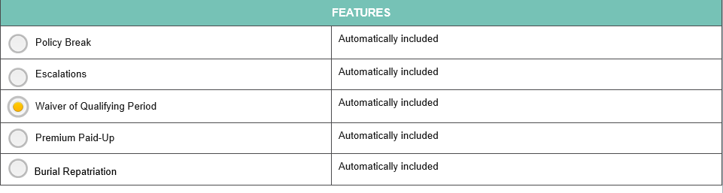

Adding or removing cover

- Funeral cover, Life cover and Monthly Expenses cover can be added to the different life types.
- Each cover has its own premium and can therefore be added and removed at the policyholder’s request.

  - Policy Break description

- If the policyholder needs to they can apply to keep the Policy active for up to 12 months without making any monthly premium payments.
- The policyholder can restart payment at any time during the 12 months at which point the cover will be identical to that prior to the start of this benefit.

During this payment holiday, benefits are limited to:
- R5 000 for accidental death of the principal life assured only.
- Burial Repatriation Benefit for all lives assured.

- No other benefits will be paid during the time this benefit is active.
- Only one claim is allowed for this benefit.

Life Assured
The benefit only applies to the policyholder.

Qualifying Period
There is no qualifying period for this benefit.

When will this benefit end?

This policy feature will end when:


- The policyholder resumes payment of premiums after using this policy feature
- The contract ends
- If the no more premiums benefit is exercised
- A claim was paid for the principal life assured.

Conditions
- No new lives can be added when this Benefit is in operation.
- No alterations in cover levels or will be allowed once the Benefit is in operation

  - Escalations description

The escalations are compulsory at the start of the policy.
Each year on the anniversary of the policy issue date:
- The monthly premiums will increase by the chosen premium escalation rate, times the monthly premium paid in the previous year.
- The cover selected will increase by 80% of the premium escalation, times the benefit cover level of the previous year.

Both premiums and cover escalate on a compound basis at their relevant rates.

Escalation increases
- If we do not receive the increased premium within three months of the increase becoming due, then the escalations will be stopped for that policy year, and the benefit cover level will remain at its existing level.
- Any valid claim during this three month period will be based on the increased cover level
resulting from the escalations (assuming it was payable).
- The increase in the premium owing will be deducted from the claim amount paid.
- If the increase in premium was not received in the three month period, the escalations will operate again at the next policy issue date anniversary.

Postponement of escalations
- The client can request for a postponement of their escalation in a year.
- The client can contact Sanlam to request that we do not call for the higher premium for a year, but that it will operate again from the following year.
- This results in the escalation being declined on the system and restarted the following year

Escalation rates available

- The premiums can increase at a rate of 5% or 10% per annum.
- If an escalation rate is not selected, a default rate of 5% will be applied.
- The cover amount increases at a rate of 80% of the premium escalation each year. This means that for a premium increase of 5%, the cover will escalate by 4%, and for a premium increase of 10%, the cover will escalate by 8%.

Qualifying period
No new qualifying period is applicable to the escalated cover amount.

When will the benefit end?
This benefit can be canceled at any time by the policyholder by giving notice to Sanlam.

Exclusions
The benefit does not apply to Policy Break.

  - Waiver of Qualifying period description

An insurer may not impose a qualifying period that is longer than 6 months for a funeral policy. An insurer may also not impose a qualifying period where a policyholder confirms that, within 31 days immediately before entering into a new funeral policy, had a previous policy with another insurer

If the policyholder can confirm that they and any of their lives assured had previous funeral cover 31 days before entering into this Sanlam policy with Sanlam or another licensed insurer, their qualifying period could be safe. The length of time of the qualifying period will be reduced by the amount of time already served under the previous funeral cover.

If the policyholder and life assured completed the maximum 6 months qualifying period in the previous policy, the qualifying period on the new policy will be waived in full. It Is very important to remember that a previous policy needs to be cancelled in order to waive the qualifying period.

Not taken up (NTU) cases are not included for waiver of qualifying period. To qualify for the waiver of qualifying period, the client must have been the policyholder and any lives assured, on the policy. Sanlam will be responsible for making the decision whether the policyholder or the lives covered qualify for the qualifying period to be set aside. The policyholder will be notified within 3 days of Sanlam’s decision.

Details required
In order for the waiver of the qualifying period to be considered, the client should provide the following details regarding the previous policy when they apply for the policy:

- Name of previous insurer
- Policy number/s
- Personal details of lives insured (name, date of birth and relationship to policyholder)
- Cover amount of each life’s cover
- Start date of each life’s cover (Optional) (This is not always available on the regular schedule that the intermediary gets, and might have to obtained at claim stage)
- Replacement Advice Record

Important to note that the waiver of qualifying period does not apply to all the policy features and benefits.
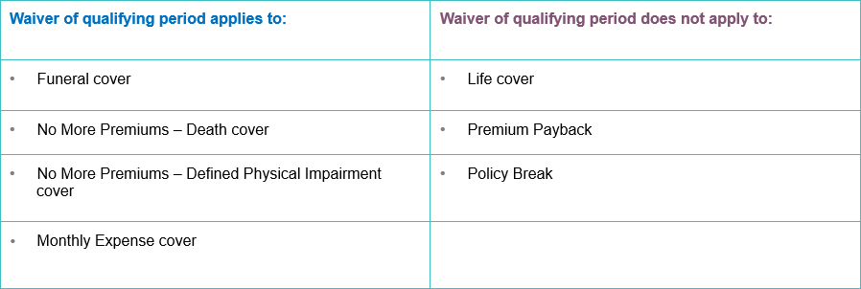

  - Premium Paid Up description

- The Premium Paid-up feature allows the policy to remain active while no further premiums are collected.
- The policy must be in an active status.

The conditions are:
- That the policy must be in force for 15 years; OR
- Policy anniversary after the Policyholder’s 65th birthday

Qualifying period
- A waiting period of 6 months applies on this benefit.
- However, the benefit will only be paid out after a 15 year period starting from the Issue Date
and the Policyholder must be older than 65.
- If the Policyholder elected to have the Cash Back paid out then they will have to pay premiums
for an additional 10 years and still meet the above requirements.
- Only premiums of lives assured that was covered for more than 10 years will qualify for this benefit

  - Knowledge Check

Classroom activity
Let us take a small quiz to test our knowledge. Select the correct option regarding the Funeral Cover.

Select the correct Answer
- Funeral cover of R20 000 is compulsory for the principal life assured.

- Funeral cover of R10 000 is compulsory for the principal life assured.

- Funeral cover is optional for the principal life assured.

Select the correct Answer
- Policy Break, Premium Pay Back, Escalations

- Policy Break, Escalations and Monthly Expense

- Escalations, Life Cover, Monthly Expense

Select the correct Answer
- The Burial Repatriation service is provided by Sanlam

- The Burial Repatriation service may be exchanged for cash

- The Burial Repatriation service may be changed or stopped at any time without notice from Sanlam

Select the correct Answer
- The qualifying period for the Double Accident Cover is 6 months

- The qualifying period for this cover is 12 months

- There is no qualifying period for the Double Accident Cover

Select the correct Answer
- There is no qualifying period for this cover.

- There is a 6 month qualifying period for this cover which begins when cover starts.
- There is a 12 month qualifying period for the Monthly Expense Cover.

Section 3: Entry ages and cover stops
Learning objectives
By the end of this section, you will be able to:
Explain the limits that apply to every benefit component on the policy per life type. Explain the different cover stops on the death of the life assured, and the whole life of the policy.

  - Life types
Cover ceases on the death of the life assured
Principal Life Assured
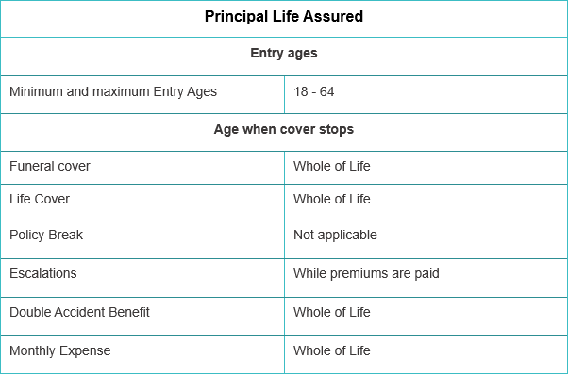

Spouse
Cover ceases on the death of life assured
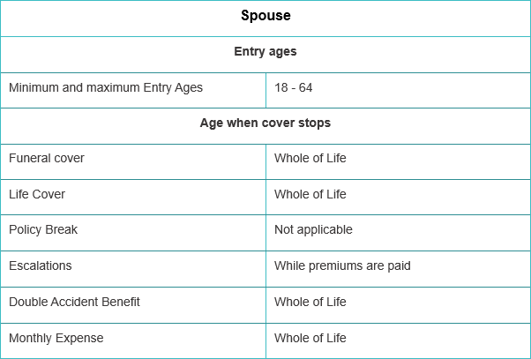

Child
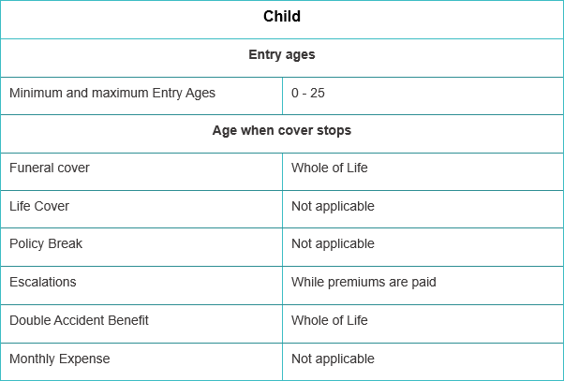

Parent
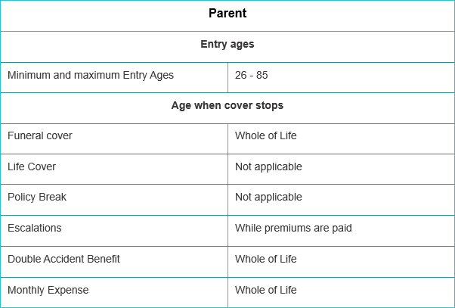

Wider Family
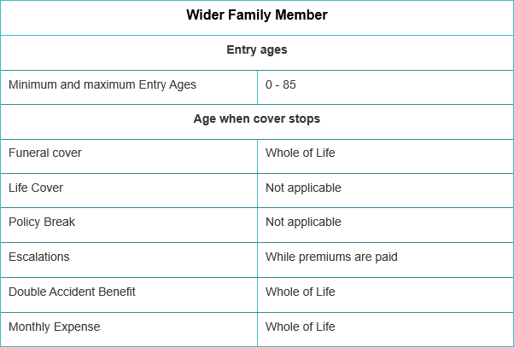

Policyholder
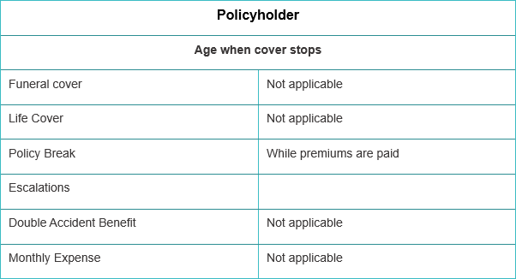

  - Number of Lives Assured
We have taken a look at the entry ages of the various life types. Let us now see the maximum number of lives that can be covered on the policy.

It is important to note that: The maximum number of lives that can be covered is 30 lives on the All in One plan.

How do we get to 30 lives covered?

1 Principal life assured:
Compulsory funeral cover
Optional life cover
Optional monthly expense cover

1 Spouse:
Optional funeral cover (1x claim over the life of the policy)
Optional life cover (1x claim over the life of the policy)
Optional monthly expense cover

8 Children:
Optional funeral cover (8x claims at any one time)

- Parents:
Optional funeral cover and monthly expense cover
4x claims for funeral at any one time
4x clams for monthly expense at any one time

16 Wider Family Members:
- Optional funeral cover and monthly expense cover
- Monthly expense cover for ages 26 and older
- 16 Funeral claims at any one time
- 16 Monthly expense claims at any one time

That sums up a total of 30 lives. Note: additional lives may be added provided it does not exceed the maximum lives permitted, also lives may be removed from the policy at any time and the premiums will be reduced.

  - Maximum cover
Now that we have the knowledge on what the entry ages are and the maximum number of lives that can be covered. We now need to know about the maximum cover limits and how they will apply.

The Sanlam All in One plan works like this in regards to maximum cover, the limits apply at the start of the new policy or when additional cover is applied for, these maximums will not place restrictions on growth in cover if you have selected premium escalations. These limits are put in place by Sanlam

The maximum accumulated cover amounts (all cover amounts) on the AiO Plan, life type are:
- Principal Life Assured and Spouse R500 000
- Children 14years and over R60 000
- Parent and Wider Family R50 000

Cover can be taken across different types of cover amounts i.e. Funeral, Life and Monthly expense cover But is subject to the accumulated limits.

The maximum limits applied to the Funeral and Monthly expenses covered are:
- Principal Life Assured and Spouse R100 000
- Children 14years and over R60 000
- Parent and Wider Family R50 000

The maximum monthly expense cover amount one can take is R36 000 for the Principal Life Assured, Spouse, Parent and Wider Family.

Also, the Maximum cover limits for children below the age of 14 are:
- Child 0 – 6 years maximum of R20 000
- Children age 6+ but before the age 14 maximum of R50 000\
  - Cover start and Cover End

When does cover start?
    - Cover starts on the day after the application is accepted on the system.
    - For increase in cover, the first of the month in which the new premium is expected to be received.
    - Addition of new life, cover starts on the first of the month in which the new premium is expected to be received.

When will the Policy End?
The policy will end on the first of:

- When the plan lapses.
- When the last life assured covered on the plan dies.
- When the policyholder submits a written request for cancellation.

On the death of the policyholder except where a No More Premiums - Death, or a No More Premium – Retirement cover applies.

No more premiums cover
The policy will end if a No more premiums cover is active when:

- The policy anniversary after the policyholder would have turned 65 under the No more premiums – Death cover
- The policy anniversary after the policyholder turns 65 under the No more premiums – Defined physical impairment cover.
- If there is fraud on the Plan. In the event that the Product Supplier determines that fraud was committed by the policyholder or the policyholder agrees that Sanlam may, with immediate effect, cancel the plan and every other plan issued by Sanlam to the policyholder.

Who will receive the benefits?
The payment of any cover on this policy is paid:

- To the policyholder, or
- If the principal life assured dies, to the beneficiary, or
- If the beneficiary is a minor, to the legal guardian, or
- If there is no beneficiary, to the executor or the policyholder’s estate
- The beneficiaries can be changed by the policyholder by request at any time.

How are premiums calculated?
Premiums payment methods allowed at the start of the policy:
  - Stop order
  - Debit order (using DebiCheck)

This product should be sold as stop order but debit order may be used if the stop order fails.
  - Premium payment methods allowed during the life of the policy:
  - All of the above and
  - EasyPay

Premiums are due monthly on the first of every month. That is one calendar month from the first of the month to pay that month’s premium.

  - Reinstatements

What is Reinstatements?
When a policy lapsed due to non-receipt of premiums, and the policyholder wishes to continue with the policy by re-activating it, is called a “reinstatement” of the policy.

What is a lapse?
A lapse is a policy status we give to a policy that is no longer active due to non-receipt of either:
- 3 consecutive (one after the other) premiums; or
- 12 premiums over the life of the policy.

What is Not Taken Up (NTU)
NTU is a policy that has been issued for a potential policyholder but no premiums have been received within 3 consecutive months from the issue date.

  - Conditions to Reinstate
Let us now look at the conditions to Reinstate a policy:
    - The client has 2 months from lapse date to reinstate their policy
    - All outstanding premiums must be paid in full within 2 months reinstatement period
    - Reinstatement forms must be completed in order to reinstate
    - Cancelled and NTU policies cannot be reinstated
Section 4: Exclusions
Learning objectives
By the end of this section, you will be able to: Explain the exclusions in the policy
Explain how the cooling off period will apply
Define the claim settlement conditions
Over and above what we have covered thus far, we have more important information we need to equip ourselves with on the general terms of the policy:

  - General Terms of the AiO
Loans
No loans allowed on this policy

Tax Treatment
All policies will fall in the Risk Policyholder tax fund (RPF).

Exclusions
We will not pay any cover amounts if the insured event happened as a direct or indirect result of:
- active participation in war
- invasion
- acts of foreign enemies
- hostilities
- illegal strikes
- warlike operations (whether war is declared or not)
- civil war, rebellion, revolution, insurrection, civil commotion assuming the proportions of or amounting to an uprising or riot, military or usurped power.

We will not pay any cover amounts if the insured event happened as a result of suicide or attempted suicide within six months for Funeral Cover and twelve months for Life Cover from the date that cover for such lives assured starts.

Cooling Off Period
The Policyholder has the right to cancel the policy and receive all premiums back within 60 days from the date of signature of the policy, provided that no benefit has yet been paid or claimed, or an insured event occurred.
Cession
Collateral cession of the life cover will be allowed on the policy. If only funeral cover, then no cession allowed.

Cession of the life cover will be allowed on the policy by way of a security cession whereby policyholder may cede the life cover plan as security to one other party, where this party may be a natural person, trust or institution.

Claim settlement

- Sanlam will not pay any claims for any cover where the event happened before cover started.
- Sanlam has the right not to pay a claim on any life assured covered until all claim
requirements have been met.
- If any information that you have provided on any life assured is incorrect, any benefit that becomes payable may be recalculated or declined.
- The client will be responsible for the costs of obtaining all relevant medical records and submitting them to Sanlam.
- Any outstanding premiums will be taken off any claim payment before the payment is made.
- If Sanlam rejects or declines any claim, such a claim will lapse and be of no force or effect unless an action has been instituted against Sanlam within three years of the claim being rejected.
- If a claim is determined by Sanlam to be based on fraud and rejected by Sanlam on the ground of fraud, Sanlam has the right to cancel the policy with immediate effect.
- If this happens, no benefit will be payable and premiums received prior to cancellation will not be refunded.
- The client will thereafter be unable to participate in the policy or any other policy with Sanlam

For all claims, Sanlam will consider claims for benefits on receipt of:

- A fully completed claim form
- Certified copy of the claimant’s identity document or Passport
- Copy of a bank statement showing the account holder’s name and surname, bank account number and branch code of the Beneficiary
- Any other documents / reports which Sanlam needs to assess the claim

For Funeral Cover and Life Cover claims, Sanlam will consider claims for benefits on receipt of

- Certified copy of the death certificate
- Police report in the case of Accidental death
- Certified copy of the deceased’s identity document or Passport
- Fully completed BI-1663/BI-1680 or DHA-1663/DHA-1680

For Defined physical impairment claims, Sanlam will consider claims for benefits on receipt of:

- Evidence to the satisfaction of Sanlam that the physical impairment event claimed for
meets the requirements of the definition of the claim event.

Residence, Travel and Occupation

All Principal Lives Assured must be permanently living in the Republic of South Africa at the
start of cover.

All other assured lives can be a resident within the following countries at the start of cover:

- Republic of South Africa
- Swaziland
- Botswana
- Mozambique
- Lesotho
- Namibia
- Zimbabwe

Benefits will not be paid to the beneficiary for a life assured who permanently resides in or who, for a period continuous longer than 3 months, resides in a country not listed above.

The policy provides cover to South Africans or South African residents that can provide:

- Proof of residency (provided by Department of Home Affairs);
- Proof of citizenship and copy of bar coded ID (provided by Department of Home Affairs for Foreigners);
- Permanent working permits with a copy of the life assured’s Passport.
Communication

Sanlam will only accept communication as having been received if:

- Sent by registered post
- Handed in at a Client Service Centre
- A voice communication with the Client Contact Centre on 0861 235 433
- An email was sent to the Client Contact Centre at info@sanlamsky.co.za
- Communication via WhatsApp 0861 235 433 or
- a fax to the Client Contact Centre on 0861 235 329, where proof of transmission may be requested.

Communication in any other way will only be valid if confirmed in writing by Sanlam.

Version 1.0
This learning module was developed in June 2022.

DISCLAIMER
Although Learning and Development has taken care to ensure the accuracy of information contained in this manual, we take no responsibility for intern changes not yet reflecting in this document.


Thankyouforattending thecourse!
Classroom valuation

In our efforts to constantly improve our service to our clients we will appreciate your feedback. The evaluation consists of 12 questions and will only take a few minutes of your time.

The evaluation will assist us with the following:
- Course material
- Trainer
- Impact on trainee

A. Please indicate your rating on a 5-point scale (1 = Very Poor 5 = Excellent)
Course name: Sanlam All in One
Date of the course
Coursefacilitator
B. Evaluation of Course
The following points of evaluation are with regard to the course contents. | Very Poor | Poor | Average | Good | Excellent
 | 1 | 2 | 3 | 4 | 5 | n/
Thecourse content has addressed my performance needs.
The course was sensible and easy to understand.
Course duration.
C. Evaluation of Trainer
The following points of evaluation are to evaluate the trainer. | 1 | 2 | 3 | 4 | 5 | n/a
Subject Knowledge.
Presenter/Trainer’s professionalism.
Responsetoquestions.
Ability to link theory to practical examples.
Effective use oftechnology.
Preparation.
D.Impact
The following points of evaluation are to evaluate the impact of the course on you, the learner. | 1 | 2 | 3 | 4 | 5 | n/a
Thecourseincreasedmyskills/knowledge.
Skills/knowledge gained are directly applicable to my job.
I have a plan of action to implement these skills to my job.
E. Additional
Please add any additional comments / suggestions with regard to the training in the space below.

Version 1.0 Page 38



